**FELLOWSHIP AGREEMENT**

This agreement, dated **07 Aug 2025** is made between **Buildables** and **Aleena Jabeen**

This document constitutes the fellowship completion agreement allowing all parties to understand all their objectives and goals clearly. This makes for less uncertainty and prevents future unexpected disputes to occur. Furthermore, the agreement between the fellow and Buildables is governed under the laws of the Islamic Republic of Pakistan.

**Participation (**The Fellow must agree to the following)

1. The fellow will attend all the sessions as scheduled on the specific dates. The fellow will actively participate and complete the 3 months fellowship program to maximize its benefits.
2. The fellow will stay committed and complete all assigned tasks.
3. In case, a fellow decides to leave the fellowship in the middle, will be charged a financial penalty. The amount of the penalty will be decided by the management.
4. The Fellow does not have to pay anything, this is totally free of cost.

**Buildables offers**

1. Buildables will assist in providing productive and helpful career guidance through different Tasks & sessions
2. Certificates will be provided to each participant upon completion of this Fellowship program.
3. A recommendation letter will also be provided. Recommendations can also be provided by personal references **who can attest to an applicant’s character and abilities.**
4. Under direct guidance from Buildables mentors & leads, you will be creating real-world projects to showcase your skills.
5. At the end of this fellowship, Top Performers will be eligible to work with Buildables on projects in a partnership basis.
6. In case any development project is referred/outsourced to Buildables, the fellow will get 10% of the original project cost upon completion.

**Understanding**

It is mutually agreed upon and understood by and among the parties of this agreement that:

1. Each party will work together to fulfill its obligations for the duration of the program.
2. This agreement does not forbid either party from participating in similar agreements with other public or private agencies, organizations, and individuals.
3. This agreement will be effective upon the signature of both parties.
4. The Fellowship program consists of atleast 5 active days per week, Saturday & Sunday can be off.
5. The fellow will work at his/her own pace because of flexible hours and fully remote work.
6. The fellow is free to work part-time, full-time, or freelance in any capacity alongside the fellowship, and Buildables does not forbid the fellow in any way, shape, or form as long as the fellow is completing all of his/her assigned tasks.
7. If the fellow doesn’t fulfil the terms of this agreement, he will be removed from the program and will not be entitled to any of the benefits provided by Buildables.

**Aleena Jabeen**                                                   **aleenajabeen19648@gmail.com**

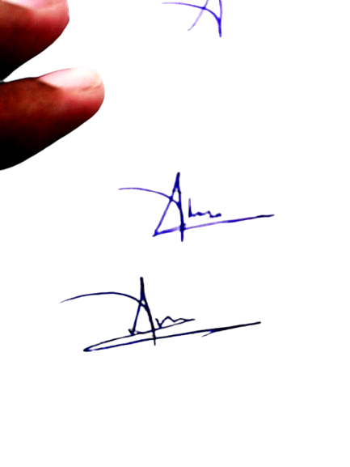Fellow Full Name                                                                       Email Address

_______________________                                                          **3740592627638**

Signature                                                                       CNIC Number